About me

What I want you to call me:
My name is Eden
This is pronounced E-den


E D E N


About me
I work as the Young Person’s Engagement Officer.
My job is to make sure children and young people with Special Educational Needs and Disabilities (SEND) get to impact how the service is run as experts using their lived experiences.

What is important to me
☑ Helping people who need our service
☑ Eating lots of yummy food
☑ Spending time with my family, my friends
☑ Exploring new places in London and beyond

How you can support me
If there is something you don’t understand please let me know! 😊
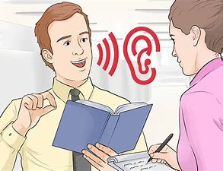
I can talk quite quickly sometimes, ask me to slow down.

Ask me as many questions as
you like. I want to make sure the service is something that works for you

